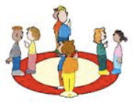

Dear Room 1 Families-

The Kindergartners are so excited to share during Morning Meeting. Starting next Thursday, our “share days” will be Thursday and Friday. On share day , children can bring something to share with the class. The rules are:
A share needs to be:
- Something from nature
- Something a child made
- A photograph of an experience and/or a person they would like to tell the class about
- A story to tell
When the Kindergarteners come to school, there will be a place to sign up for share. Children may only share once a week (either on Thursday or Friday), but they can choose their day each week. It is optional to share- Sharing is a part of our morning meeting where children are practicing their oral language, caring and learning about their friends, and the conventions of asking questions.

We appreciate your help in guiding your child to follow our share rules and to make sure that his/her share is appropriate for the classroom.

Please let us know if you have any questions-
Ilana and Jessica
